

Double-click the sha256internalrootchain.zip file embedded above to view contents.

Double-click the AICA01.cer within the .zip file. Then click the Install Certificate… button.

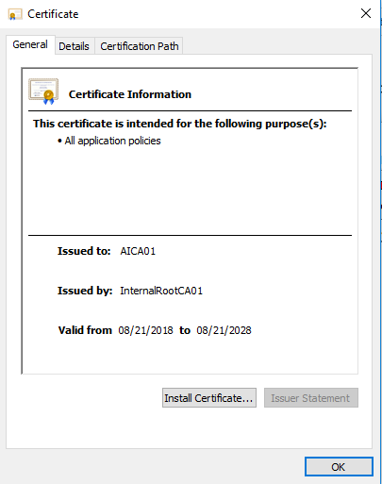

Current User should be the default store, click Next.

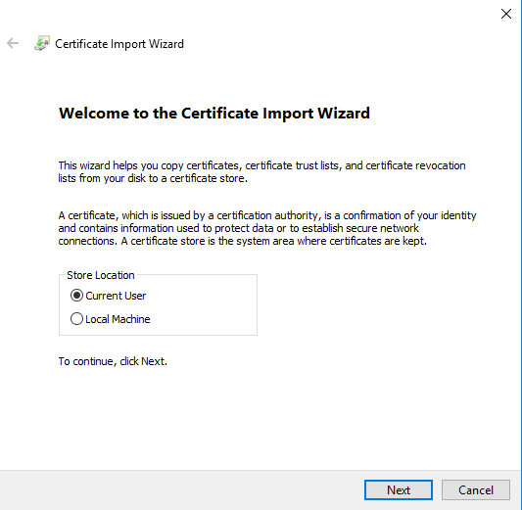

Choose the “Place all certificates in the following store” option, then click Browse…

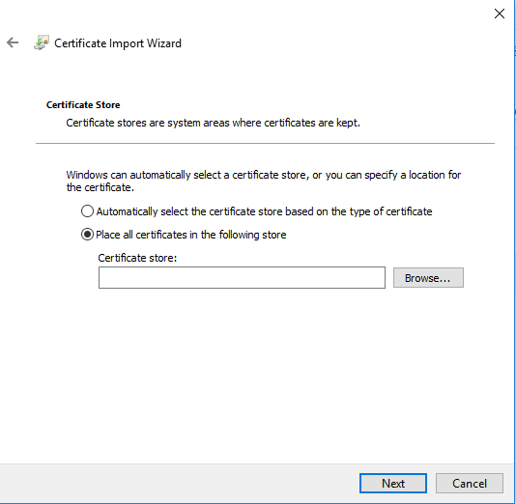

Select the Intermediate Certification Authorities, then click OK, then click Next, and finally click Finish.

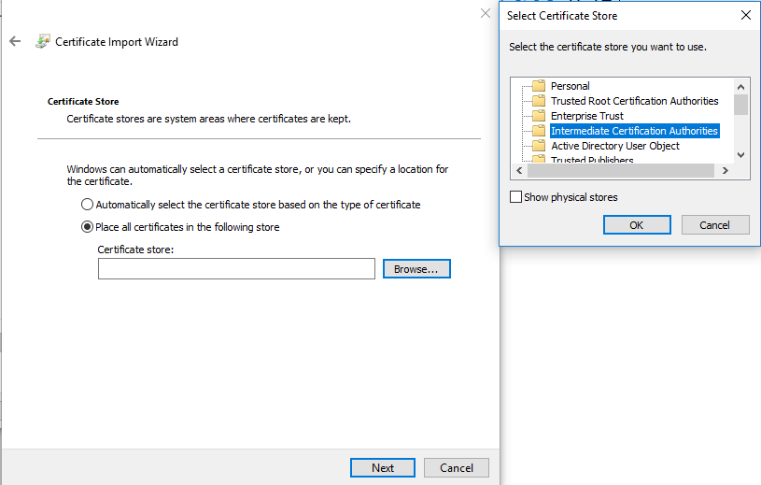







Now install the InternalRootCA01.cer with the same process as above, only choose a different certificate store (Trusted Root Certification Authorities), as pictured below.

